|  |  |
| --- | --- |
|  |  |
| **Connected Vehicle Trajectory  Sanitization  Algorithm** |  |
| Jason M. Carter, PhD  Aaron E. Ferber | March 27, 2017 |

|  |  |  |
| --- | --- | --- |
| Revision | Date | Changes |
| 0.8[1] | 9/16/2016 | * Initial Version |
| 0.9.13 | 3/27/2017 | * Updates for transition to electron GUI. * Added the Adv. Configuration tab * Updated the Introduction. * Added the Concepts section to better explain the parameters. * Started to build the verification section. |
| 0.9.14 | 3/28/2018 | * Added section about data limitations (GPS Errors) |

Table of Contents

Table of Figures 6

Part 1: Introduction 7

Motivation 7

De-identification Purpose and Objective 7

Data De-identification vs. Data Utility 8

Part 2: De-Identification Algorithm Concepts 9

De-Identification Nomenclature 9

Map Preprocessing 10

Map-Fitting 11

Explicit Box 12

Implicit Box 13

Basic De-Identification Algorithm 13

Critical Interval Metrics 15

Trip beginning and endpoint detector 15

Vehicle turnaround detector 15

Vehicle stop detector 15

Privacy Interval Metrics 16

Direct Distance 16

Manhattan Distance 16

Intersection Out-Degree Count 16

Which criterion to use 17

Minimum and maximum values 17

Randomness values 17

Data Limitations and Data Error Handling 18

Part 3: Route Sanitizer User Interface 19

Introduction 19

Installation 19

General Layout of User Interface 21

User Interface Elements 22

Button 22

Text Box 22

Numerical Box 22

Slider 23

Tooltip 23

Workflow Outline 23

OSM (Open Street Map) 24

Input Files 25

Configuration 27

I/O 27

CSV Field Names 28

KML Options 28

Privacy Intervals 29

Adv. Configuration 31

Map-Fit 31

Critical Intervals 32

Privacy Intervals (Advanced) 33

Map 34

Verifying Sanitized Trip Files 35

Logging 36

User Interface Logging 36

De-identification Run Logging 36

Multi-threading 36

Appendix A – File Formats and Directory Structures 37

OSM Files 37

Quad Files 37

Input CSV Files 38

Output Directory and File Name Structure 38

# Table of Figures

Figure 1: De-identification Intervals. 9

Figure 2: Map-fit using Implicit and Explicit boxes. 10

Figure 3: Explicit map fitting box geometry parameters. 11

Figure 4: Annotated De-Identification Results (Google earth, Image Landsat). 13

Figure 5: Intersection Out Degree 16

Figure 6: RouteSanitizer Welcome tab. 20

Figure 7: RouteSanitizer OSM tab. 23

Figure 8: RouteSanitizer OSM tab, OSM bounds retrieved from OSM file. 24

Figure 9: RouteSanitizer Input Files tab, load files. 25

Figure 10: RouteSanitizer Input Files tab, remove files. 25

Figure 11: Configuration tab, I/O parameters. 26

Figure 12: Configuration tab, CSV Field Name parameters. 27

Figure 13: Configuration tab, KML Options. 28

Figure 14: Configuration tab, Privacy Intervals parameters. 29

Figure 15: Adv. Configuration tab, Map-Fit parameters. 30

Figure 16: Adv. Configuration tab, Critical Intervals parameters. 31

Figure 17: Map tab, KML file loaded. 33

Figure 18: OSM XML file example. 35

Figure 19: Quad file example. 35

Figure 20: CSV input file with vehicle trajectories. 36

# Part 1: Introduction

## Motivation

Connected vehicle technology uses in-vehicle wireless transceivers to broadcast and receive basic safety messages (BSMs) that include accurate spatiotemporal information to enhance transportation safety. These devices rely on integrated Global Positioning System (GPS) measurements to improve driving safety. Databases, some publicly available, of BSM sequences, called trajectories, are being used to develop safety and traffic management applications. BSMs do not contain explicit identifiers that link trajectories to individuals; however, the locations they expose may be sensitive and associated with a very small subset of the population; protecting these locations from unwanted disclosure is important. Public sector policies require research data that is made publically available should be recorded in such a manner that subjects cannot be identified, directly or through identifiers linked to the subjects. A procedure that minimizes the risk of associating trajectories with individuals, or de-identification, is necessary to meet open data requirements.

## De-identification Purpose and Objective

We consider Personally Identifiable Information (PII) as information that identifies an individual or their characteristics *directly*. Other types of data are more appropriately classified as *personal information* since it pertains to an individual, but it does not directly identify an individual [NIST SP 800-188]. For a connected vehicle, a sequence of BSMs also describes the spatiotemporal trajectory of its human operator.

Operator privacy is a principle concern as applications are being developed using trajectory databases. Removing direct identifiers and any static fields that reduce identifiable subpopulations is only the first step. Frequently-visited locations, travel patterns, religious and sexual preferences, social customs, and driving characteristics are examples of information that can be inferred from vehicle trajectories.

*De-identification* (a.k.a. *sanitization*) is a process that seeks to minimize the possibility of associating personal information, to include identifying information, with a data subject [NIST SP 800-188]. Successful identification of an individual whose identity has been ostensibly obfuscated by de-identification is *re-identification*. We differentiate de-identification and *anonymization*; the latter implies re-identification is rendered impossible [NIST SP 800-188]. Perfect de-identification is difficult, if not impossible. However, effective de-identification techniques reduce the chance for inadvertent exposure of a person’s private trip data to adversaries.

Re-identification is becoming more and more of a concern in the age of big data. While a single piece of information may be innocuous on its own, it could be linked to other, often public, data sources to begin to build a dossier about a person that could be used in unwanted ways. For trip data, this can be as easy as using the termination point of the trip to lookup a street address (known as reverse geocoding) and then use the street address to lookup the resident’s names (using a variety of on-line tools). Usually, the details we can learn from a single trip do not pose that much of a privacy risk; but, when many trips are associated with a particular individual, the risk to individual privacy grows.

Initially, the de-identification task seems straightforward: remove the endpoints or create safe zones (geofences) where privacy is not needed. This has been shown to be insufficient, so we need a better way of approaching the de-identification task. Another reason the straightforward approach is insufficient is each person defines privacy differently; some location in the middle of a trip may be more sensitive than a trip’s termination points. How do we generalize determining which locations should remain private and which are acceptable to release? Furthermore, how do we “protect” those locations from individuals having access to different types and amounts of auxiliary information that might aid the re-identification task using different amounts of skill. How do we account for different types of road layouts? A standard method for de-identifying spatiotemporal trajectories has yet to be established; however, this algorithm makes de-identification adaptable by providing the data steward parameters to balance privacy protection and data utility.

## Data De-identification vs. Data Utility

Privacy-preserving data is published for analysis to improve technology and enhance situational awareness. The types of research that can be conducted and its accuracy depend significantly on how the data has been modified. Our de-identification procedure was not developed for a particular use case. As connected vehicle applications are still under investigation, to utility of de-identified data in specific scenarios continues to be evaluated with specific attention being given to traffic management and analysis applications.

Data utility describes how useful a form of data is in accomplishing a particular objective. Some de-identified data may facilitate accomplishing the objectives of a particular data application while the same data may be useless for another task. Data utility depends on the data application’s objective. Balancing data de-identification and data utility is a dilemma: researchers and technology developers may make huge breakthroughs without a care in the world about individual identities when given original data, but malicious parties will use the same data for personal gain or to the detriment of another party by purposely associating the information with an individual. Our goal as data stewards is to provide data that can still be useful to researchers and technology developers, but makes the re-identifier’s job extremely difficult.

Open data research will improve connected vehicle technology and lead to new uses for this valuable resource. Furthermore, open data research increases the transparency of the connected vehicle program, and it may ease individual concerns about privacy by showing that such data can be released in de-identified form with minimal risk to individual privacy.

# Part 2: De-Identification Algorithm Concepts

This section of the manual describes the de-identification algorithm used in Route Sanitizer in enough detail to understand how the user-modifiable parameters on the Configuration and Adv. Configuration tabs affect the algorithm.

The de-identification process is separated logically into 5 subprocesses. Each subprocess is controlled by a set of parameters that can be used to tune de-identification depending on the acceptable risk. The de-identification subprocesses, and the tab in the Route Sanitizer user interface where the parameters can be modified, are:

1. map preprocessing (OSM tab),
2. fitting trajectories to maps (Adv. Configuration tab),
3. detection of critical intervals (Adv. Configuration tab),
4. generation of privacy intervals (Configuration and Adv. Configuration tabs), and
5. final point suppression.

Users who want to change any of the parameters on the Configuration and Adv. Configuration tabs should have a good understanding of the algorithm basics and how various parameters affect the algorithm before making changes to the default values.

Each of the de-identification subprocesses is described in the following sections, preceded by a section defining the de-identification nomenclature used in the descriptions. Each subprocess section describes the basic algorithm theory and how the user modifiable parameters affect the algorithm.

## De-Identification Nomenclature

A ***trip****,* or***trajectory****,* is a time-ordered, sequence of records (tuples) that are generated using BSM information. Each record includes, at a minimum, the time, a ***geopoint*** (latitude, longitude), a heading, and speed. In Fig. 1, the gray dashed line represents an original trip; the individual dashes represent the records that make up a trip. A ***trip (trajectory) subsequence*** is a subset of records with the same order relation; records in a trip subsequence do not have to be adjacent with respect to the original trip sequence – a single subsequence may have gaps where records have been removed. On the other hand, a ***subtrip*** is a trip subsequence with no record gaps between the subtrip’s first and last record with respect to the original trip (blue dashed line in Fig. 1). A ***prefix subtrip*** is a subtrip that includes the first record in the trip; a ***suffix subtrip*** is a subtrip that includes the last record in the trip.

The term ***feature*** is used to describe a subtrip that represents some unique and distinguishing characteristic of the trip; it may be based on vehicle behavior, geographic position, or position within the original trip.

The term ***uncertainty*** is used periodically throughout this document. For our purposes, uncertainty is characterized from the perspective of the re-identifier: when we introduce uncertainty the re-identifier’s job becomes more difficult – this is one objective of de-identification.

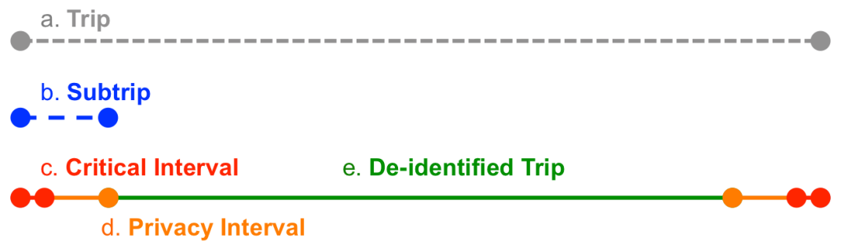

Figure : De-identification Intervals.

A ***critical geopoint*** is a geopoint that may contribute to re-identification. Critical geopoints are candidate locations that require additional analysis to determine whether or not they pose a risk to individual privacy. For example, a geopoint that places a vehicle in a driveway is a critical geopoint independent of whether that driveway is connected to the driver’s home or not. In some cases, criticality is based on behavior rather than geography. To address both location and behavior, we define a ***critical interval***as a subtrip that includes only critical geopoints; a critical interval can occur anywhere in a trip. The red subtrips in Fig. 1 represent critical intervals.

Critical intervals are removed during de-identification along with intervals that extend from either side of a critical interval to introduce additional uncertainty; these additional intervals are called ***privacy intervals***. The two orange segments in Fig. 1 represent different privacy intervals. Together, these privacy intervals form a trip subsequence. Similarly, the critical interval and privacy interval at the beginning of the trip (marked c. and d.) together make up a subtrip – there are no geopoints between these two intervals. The subtrip they form is also a prefix subtrip. A critical interval at the beginning or end of a trip can only be extended in one direction.

Due to the way in which distance and GPS jitter can affect the de-identification process, we need to distinguish between critical and privacy intervals. For example, a driver that sits in his or her driveway for 20 minutes has covered no real distance; however, the GPS jitter may have induced an artificial distance (the length computed will depend on the loiter time). This small artificially induced distance is included in the critical interval, so it will not unnecessarily influence how the privacy interval is created. If it were included in the privacy interval, then it could skew de-identification in the re-identifier’s favor by not introducing enough uncertainty.

## Map Preprocessing

The robustness of the de-identification process can be improved by integrating map data from Open Street Map (OSM) files. The OSM information used includes:

* A geographically anchored graph (i.e., labeled edges and vertices) is constructed from OSM nodes and ways (a sequence of segments). To accommodate curvature, OSM may use hundreds of segments (edges) to define a single way (i.e., road); each segment is a straight line between two distinct nodes (i.e., geopoints, vertices).
* The number of segments (edges) that come together at an intersection. This is called the degree of a vertex; it corresponds to the choices a driver, or re-identifier, has when encountering the intersection.
* OSM highway type.

Since the OSM files contain more information than the de-identification algorithm requires, Route Sanitizer provides a tool on the OSM tab to reduce and format the OSM information into a form that the sanitization algorithm can use more efficiently. An option to limit the map data to within a specified geographical area is included. The reduced map information is output to a “quad” file. Currently, Route Sanitizer can only use quad files containing reduced OSM data for the map-fitting process.

## Map-Fitting

BSM input files contain data which defines trips as a sequence of line segments. OSM map files contain data which defines roads on a map as a sequence of line segments. The basic idea in map-fitting is to find the road line segments in the OSM file which most closely match the trip line segments in the BSM input file. If road network specifications in OSM files were always reliable and GPS measurements always accurate, then this matching of line segments would be easy. In practice, quality issues exist with both and an efficient approach to map-fitting is needed.

The Route Sanitizer algorithm uses two constructs in the map-fitting process and the number of user modifiable parameters associated with each:

1. Explicit Box (3 parameters)
2. Implicit Box (2 parameters)

An explicit box (purple boxes in Fig. 2) is used for matching BSM trip segments (thin line inside boxes in Fig. 2) to OSM road segments (e.g. white highway lines in Fig. 2). If a match cannot be found, the algorithm then constructs an implicit box (red boxes in Fig. 2) for the trip segment. Several user changeable parameters on the Route Sanitizer Adv. Configuration tab are used to control the explicit and implicit box map-fitting. The default configuration settings work well in most cases, and we recommend leaving them alone unless new settings have been verified through experimentation and KML inspection.

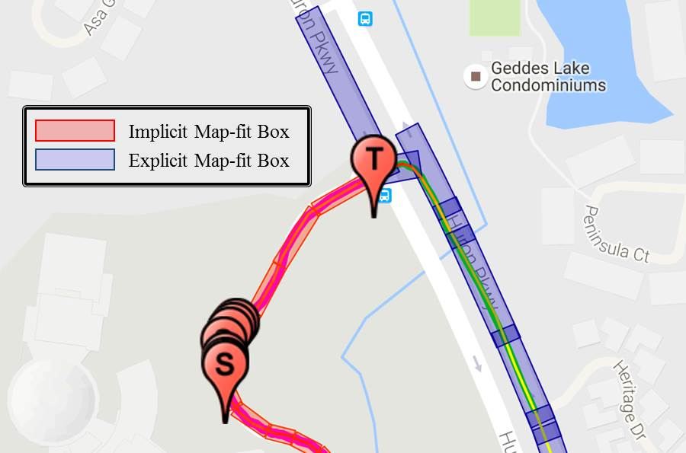

Figure : Map-fit using Implicit and Explicit boxes.

### Explicit Box

The sanitization algorithm attempts to identify the OSM road segment associated with the physical road that the driver was originally on when their on-board equipment (OBE) or vehicle-aware device (VAD) generated the BSM record captured in the trajectory file. This map fitting process is made easier by encapsulating each OSM road segment in an “explicit box.”

Fig. 3 illustrates the geometry of an explicit box that encapsulates an OSM road segment (red line segment in gray box). The dimensions of each box are determined by the length of the OSM segment and several user input parameters. In Fig. 3, the outer box represents the default box and the darker shaded inner box is a scaled boxed determined by input parameters and used in the de-identification process. The map-fit extension length and width scaling factor parameters used in determining the scaled box are discussed in more detail below.



Figure : Explicit map fitting box geometry parameters.

#### Map-fit extension length

Each box can be extended beyond the endpoints of the encapsulated OSM road segment. The amount the box is extended on each end is specified by the extension length. Each box has two edges that run perpendicular to the road segment (the left and right ends of the boxes in Fig. 3). If you specify a zero extension length, these edges are constrained to intersect the road segment at each end in the map fitting process. Because the OSM map may not accurately represent the road location, setting this parameter to zero may make the map-fitting process more difficult and less accurate overall. When non-zero, the box edges are no longer forced to intersect the OSM segment it contains; there is an “error” factor introduced that may help the accuracy of map fitting in certain intersection configurations.

#### Map-fit width scaling

The highway types for segments specified in OSM are used to infer the width of the road a vehicle travels on (e.g., highways have multiple lanes and are wider than single lane residential roads), and accordingly the width of the box used in map fitting. The width dimension used for each highway type is fixed in the sanitization algorithm, but can be adjusted using a scaling factor to obtained a box that is wider or narrower than the fixed settings (e.g., actual width = scale factor x OSM road width). A scaling factor of 1.0 leaves the values unchanged; a scaling factor of 0.5 makes the boxes half as wide as the pre-specified road width; a scaling factor of 2.0 makes the boxes twice as wide. The same scale factor is applied to all roads regardless of the OSM highway type. An on/off user input parameter controls whether or not the scale factor is “enabled”, i.e., applied, during the de-identification process.

The sanitization algorithm is more efficient when trajectory points are contained within a “fit” box. When GPS measurements drift, the measurements may necessitate initiating a new search for the OSM segment that corresponds with the drifting trajectory point. Width scaling is used to accommodate some drift without a significant drop in sanitization performance.

### Implicit Box

In some cases, an OSM road segment may not exist for a road being traveled by a connected vehicle. In these cases, the sanitization algorithm generates “implicit” boxes that it uses to detect certain types of behavior that might be associated with private locations. How these implicit boxes are constructed is determined in part by the two user input modifiable configuration parameters.

#### Implicit Heading Groups

A vehicle does not change its heading significantly when it travels on a straight road segment. In order to capture this type of behavior, the face of a compass (e.g., 0 to 360 degrees), a.k.a. “compass rose”, is divided into quadrants. While a vehicle’s heading remains within a particular quadrant, we assume the vehicle remains on an “implicit” road segment, an unknown or unspecified OSM road segment. The Implicit Heading Groups configuration parameter determines the size of each quadrant indirectly by specifying the number of equally sized quadrants to divide the compass rose into. For example, but default the compass rose is divided into 36 quadrants; each quadrant is 10 degrees.

#### Minimum Implicit Edge Trippoints

Sometimes GPS measurement errors manifest as rapid heading changes. The Minimum Implicit Edge Trippoints configuration parameter specifies the minimum number of trajectory points that must be contained in an implicit box before a new one is created.

The above configuration parameters work together to “infer” unspecified OSM road segments; the segment bisects the “implicit” box. These are usually associated with parking lots, drive ways, or access roads. An implicit road segment will never contain fewer than “minimum implicit edge trippoints” even when the vehicle’s heading has deviated outside of a given quadrant.

## Basic De-Identification Algorithm

Fig. 4 depicts a trip to which the Route Sanitizer de-identification procedure has been applied. The de-identification algorithm processes each trip subsequence to 1) identify critical intervals and 2) remove critical intervals and privacy intervals. The algorithm deploys “detectors”, i.e., code algorithms that detect where or when something happens, to locate the critical intervals. During de-identification, each privacy interval is constructed by examining the records that occur immediately prior to the first record in the critical interval and immediately after the last record in the critical interval. Various metrics and parameters are used to tweak the de-identification process to ensure that adequate uncertainty has been introduced to the trip for privacy.

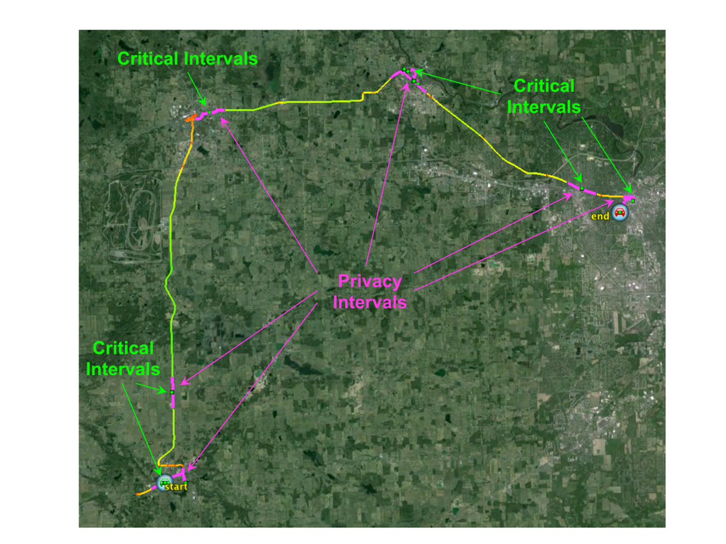

Figure 4: Annotated De-Identification Results (Google earth, Image Landsat).

During the de-identification process, the algorithm applies the following assumptions and rules to determining the critical and privacy intervals:

1. A **critical interval** must be non-empty. Accordingly, each **critical interval** can be characterized by a set of features that characterize our general idea of personal privacy.
2. For each **critical interval**, there exists a set of parameters that determine the sensitivity of the detectors that find locations having characteristics that make them private.
3. A **privacy interval** can be empty. In this case, elimination of the **critical interval** provides sufficient uncertainty to protect the individual’s privacy. This rule allows us to generalize how **privacy intervals** are connected to **critical intervals**.
4. For each **privacy interval**, there exists a set of parameters that characterize how much uncertainty is introduced by eliminating that interval.
5. Two **privacy intervals** are associated with each **critical interval.** One **privacy interval** regresses toward the beginning of the trip; this is called the **backward privacy interval**. The second **privacy interval** moves forward in the trip; it is called the **forward privacy interval**. Together the forward and backward privacy intervals are called the **privacy region**; each **critical interval** is associated with a **privacy region**. The prefix critical interval has an empty backward privacy interval; the suffix critical interval has an empty forward privacy interval. Certain internal privacy intervals have empty privacy intervals.
6. The intersection of each **critical interval**, **privacy region** pair is empty and their union is a subtrip.
7. The intersection of all **privacy intervals** in a trip is empty, i.e., **privacy intervals** do not overlap.

## Critical Interval Metrics

As discussed previously, critical intervals characterize locations that should remain private. Since we do not have any additional information about the driver, the sanitization algorithm finds critical intervals by analyzing the characteristics of trajectories. Route Sanitizer uses “detectors”, i.e., coded software algorithms whose function is to detect something, to locate critical intervals. The 3 defined detectors used by Route Sanitizer, and the number of user modifiable parameters associated with each detector, are:

1. Trip beginning and endpoint detector (0 parameters),
2. Vehicle turnaround detector (4 parameters),
3. Vehicle stop detector (3 parameters).

Trajectory points associated with certain types of GPS errors are automatically removed independent of the above critical interval detectors. GPS units can “park” themselves at the poles or equator prior to acquiring enough satellites to determine their position accurately. These points can cause the de-identification algorithm to incorrectly determine what needs to be removed; in some cases, it can lead to private locations remaining in the final trajectory file. Accordingly, these points are removed prior to any determination of what should be removed.

### Trip beginning and endpoint detector

Beginning and endpoint detection is always active and has no associated parameters. After GPS error points have been removed, this detector marks the beginning and endpoints of each trajectory as critical. Based on numerous studies, beginning-end point pairs are highly distinguishing.

### Vehicle turnaround detector

Turnarounds are only detected when the speed of the vehicle is below a user modifiable maximum speed parameter. Two different strategies are used for detecting turnarounds:

1. One strategy retains a queue of consecutive implicit boxes (the trajectory is not on an OSM segment). User modifiable parameters include the maximum queue size, i.e., the maximum number of implicit boxes that can be maintained on the queue, and the width of the generated implicit boxes. When the queue list reaches its maximum size, the oldest box in the list is removed prior to adding the new box. If a vehicle re-enters an implicit box in this list, a turnaround critical interval is generated. Wider boxes increase the likelihood of detecting a turnaround, but could also lead to detecting behavior that should not be considered a turnaround (i.e., a false positive). This strategy operates based on the idea that turnarounds on well-defined roads will not be considered private (there are other ways to detect behavior on well-defined roads that may be considered private).
2. Another strategy retains the heading of the vehicle when it leaves an explicit box (e.g., a box that encapsulates an OSM road segment) and compares that heading to the heading of the vehicle when it re-enters an explicit box. If the heading delta (i.e. difference) exceeds the threshold defined by a user modifiable parameter, a turnaround critical interval is generated. Again, we are attempting to identify portions of trajectories that are not on well-defined roads. When no map information is available the first strategy continues to work well; however, the second strategy will not work since it relies on explicit boxes.

### Vehicle stop detector

Stops are detected in two phases based on several conditions. First, travel on certain road types and at speeds exceeding a threshold are not analyzed for stop-like behavior. When a vehicle’s speed drops below the speed threshold, and it is *not* on one of the designated road types, stop-like behavior is defined based on total distance traveled over a predefined time-period. The speed, minimum distance, and maximum time thresholds are all user modifiable parameters.

For example, assume traveling less than 15 meters in 2 minutes is stop-like behavior (this equates to an average velocity of 0.28 mph). Since GPS error may affect speed measurements, a vehicle whose velocity becomes 0 may never record a 0 speed. Likewise, a vehicle caught in a traffic jam should not be flagged as a stop even though their velocity could be 0 for a while. Our definition of a stop does not use velocity directly.

## Privacy Interval Metrics

As discussed previously, privacy intervals “protect” critical intervals by determining how much of the trajectory surrounding the critical interval should be removed. The amount removed depends on a criterion that is defined using the following 3 metrics:

1. Direct Distance
2. Manhattan Distance
3. Intersection Out-Degree Count

Each of these 3 metrics includes a minimum and maximum parameter value as well as a randomness parameter value for a total of 9 parameters used to control privacy intervals.

### Direct Distance

Direct distance is the distance between the start of the privacy interval and the trip point currently being evaluated during de-identification (i.e., the point-to-point distance). This metric provides a radius of protection around each critical interval.

### Manhattan Distance

Manhattan distance is the actual distance traveled over the road network; this is computed using the explicit and implicit boxes generated during map fitting. By using the OSM or implicit edges the metric is made more accurate as it removes some of the GPS error introduced by the sensor. If the road network is complex with many angles, particularly acute angles, this value could be much larger than direct distance. In most cases, Manhattan distance is a better measure to introduce uncertainty than direct distance.

### Intersection Out-Degree Count

Out-degree is the number of possible directions a driver could choose at a particular intersection. Assume a driver is approaching the green dot in the center of Fig. 5 along the path indicated by the red arrow. The out-degree of this intersection is three, since there are three possible choices they “could” take. As a trajectory is being de-identified, the intersection out-degree is accumulated from the start of a privacy interval to the endpoint of a segment that defines an explicit box. Intersection out-degree count has the most direct correlation to uncertainty.



Figure : Intersection Out Degree

### Which criterion to use

The diversity of living situations across the United States presents an interesting de-identification challenge. A driver may live at the end of a very long road with no other houses on that road. In this case, distance is a poor metric to use by itself to determine when a privacy interval should be terminated. Some neighborhoods are developed around a complex network of roads that intersect with one another but have only one or two main exit points. In this case, intersection count may be the least effective measure to terminate a privacy interval, but direct distance would provide a radius of protection that could be highly effective. Also in this case, Manhattan distance may even be ineffective if the driver took a convoluted route through the neighborhood to return to his or her residence. To accommodate introducing a more general level of uncertainty, all of these measures are included in the criterion used to terminate a particular privacy interval.

### Minimum and maximum values

Each privacy interval measure condition is specified using a minimum and a maximum value. If any measure up to the current trip point exceeds the maximum threshold value, the privacy interval is terminated and de-identification stops for that “forward” or “backward” process independent of the other two measures. If a maximum condition is not met, each measure is checked against the minimum threshold values. If all of the minimum threshold values are exceeded, the privacy interval is terminated and de-identification stops for that process. If a maximum condition or all minimum conditions are not met (along with the aforementioned general criteria), the current privacy interval continues to be extended. Maximum threshold values are “safety valves” that avoid too much data loss during trip truncation; they preserve data utility. “Safety valve” values are not intended to terminate trip truncation often; they are intended to handle exceptional cases. On the other hand, the minimum threshold values (considered together) are intended as the normal means to determine when trip truncation stops. The minimum parameters ensure a certain level of uncertainty is always introduced.

### Randomness values

To provide an additional level of protection against unanticipated special cases, privacy intervals can be extended by some random distance.

The previous section describes several measures and conditions for halting trajectory truncation during de-identification. Based on the operational intent of these parameters, randomness is applied to the minimum threshold values only, since they are the “normal” means of trip truncation.

Each setting is a real-valued proportion greater than or equal to 0 and less than or equal to 1.0, e.g., 0.25 or 0.87. These values can be thought of as a percentage, e.g., 1.0 = 100%. In order to compute the random minimum for a particular condition used to determine the length of the privacy interval, the proportion value is multiplied by the difference between the minimum and maximum threshold parameters (i.e., maximum threshold value - minimum threshold value) to obtain a threshold factor (i.e., the portion of the difference to randomize). The threshold factor remains constant throughout the de-identification process. The random minimum threshold is determined uniquely for each privacy interval by multiplying the threshold factor by a real-valued random number between 0 and 1 inclusive and adding that value to use-specified minimum threshold. *If a proportion value is 0.0, no randomness will be applied.* A value of 0.0 should be used when the results of successive runs with identical parameter settings are expected to be identical (i.e., deterministic de-identification is desired for testing). On the other hand, a value of 1.0 will introduce the greatest degree of randomness to the de-identification process. Any value greater that 1.0 will be ignored since the maximum threshold value will “kick in” and halt truncation.

## Data Limitations and Data Error Handling

The de-identification algorithm handles some, but not all, data errors. The errors that are handled have been found to negatively impact the privacy protection provided by the algorithm, so their removal prior to or during de-identification is important. The de-identification algorithm is not meant to be a data validation tool, but it must perform some of these functions. The list that follows describes these errors and how they are handled:

* GPS Parking: Some GPS units “park” at one of the poles or the equator when they are initially turned on. As more satellites are acquired, a more precise object position is determined. When the initial positions in a trajectory are “parked,” large distances can be accumulated between the parked position and the first real measured position in the trajectory. These distances will trigger termination of privacy intervals prematurely leaving the sensitive locations insufficiently protected against geoposition inference attacks. Accordingly, **GPS parking positions are removed from the dataset prior to beginning the de-identification process.** If only intersection out degree is used to determine when privacy interval termination should occur, this problem is mitigated to a large degree.
* GPS Errors: Occasionally, a GPS unit will measure an inaccurate position. Similar to GPS Parking, these positions can affect the distance measurements used to create privacy intervals. The algorithm attempts to detect these position errors and remove them, so they do not affect generation of privacy intervals. Since these positions are not fixed (similar to GPS parking positions), some error may remain in the dataset and could cause de-identification errors. **GPS error points are detected and removed from the beginning and ends of trajectories.** If only intersection out degree is used to determine when privacy interval termination should occur, this problem is mitigated to a large degree.
* Data Parsing Errors: If a BSM record contains an entry in one of the key fields that is outside of the range of acceptable values and would affect the algorithm’s function, that record is eliminated. For example, if vehicle heading was less than 0 or greater than 360 degrees. **We have also found non-ASCII characters in the dataset will affect the algorithm. These should be removed prior to running the algorithm, since they cannot be parsed.**

GPS errors are particularly problematic when they are not due to parking and when they occur within a trajectory (i.e., not the first or last record). The problem is knowing which records are accurate and which records are inaccurate without having GPS precision information provided by the measurement device. In some cases, we have found trajectories where all positions are errors, but few were due to parking. Such trajectories present less risk to individual privacy because none of the positions accurately reflect the travel of the driver.

# Part 3: Route Sanitizer User Interface

## Introduction

The de-identification tool Route Sanitizer provides a graphical user interface to the connected vehicle de-identification algorithm. It uses the Google Chrome platform so it will run on different computing platforms. The basic de-identification strategy used is trip redaction: portions of a vehicle trajectory are removed. It does not alter the individual Basic Safety Message (BSM) records it retains. The algorithm integrates external map information to better protect against “inference attacks” by intelligently obfuscating locations, or introducing uncertainty. It also uses some novel mechanisms to detect locations that individuals may consider private. To tool aims to err on the side of privacy, but provides numerous parameters that allow the practitioner to adjust the sensitivity of the private location detectors as well as parameters to adjust how much of the data is removed around those locations thereby making the re-identifiers job more and more uncertain.

## Installation

Installation of the Route Sanitizer application involves downloading the application zip file, unzipping the file, and creating a shortcut for easy application launch. The process is almost identical on Windows 7/8/10 and Mac OS X. Windows screen shots are given in the main body of the user’s manual while Mac screen shots are given in Appendix A. The numbers in red circles highlight areas in the figures that pertain to certain instructions: the bracketed number in the instruction corresponds to the circled number in the figure. The steps that follow outline this process:

1. Download the RouteSanitizer zip file.
   1. If you do not already have an ORNL XCAMS or UCAMS account for accessing ORNL computing resources, please apply for an account. Generally, users who are not working at ORNL can only apply for an XCAMS account. Detailed instructions are given in Appendix B.
   2. Sign into the ORNL/ITSD Gitlab Server at <https://code.ornl.gov> using your ORNL XCAMS or UCAMS account in the “LDAP” tab.
   3. Download the appropriate zip file for your machine’s operating system:
      1. Windows 7/8/10: RouteSanitizer-win32-x64.zip
      2. Mac OS X: RouteSanitizer-darwin-x64.zip
      3. Linux: RouteSanitizer-???-x64.zip
2. Unzip the RouteSanitizer zip file.
   1. Find the downloaded RouteSanitizer zip file on your computer. If another location was not chosen during the download process, the file is likely in the “Downloads” folder.
      1. Windows: The “.zip” file name extension will not be visible if the Windows Explorer properties are set to the defaults. To change the properties so that file name extensions are visible, follow the instructions at <http://www.thewindowsclub.com/show-file-extensions-in-windows> or <https://www.bleepingcomputer.com/tutorials/how-to-show-file-extensions-in-windows/> .
      2. Mac: The “.zip” file name extension is visible by default.
   2. Double click on the RouteSanitizer zip file.
      1. Windows: Click on “Extract all files” in the upper left bar of the new Explorer window that pops up. Choose a location for the extracted files in the pop-up window. We suggest deleting the “RouteSanitizer-win32-x64” portion of the default location for the extracted folder as its inclusion will result in 2 levels of folders both named “RouteSanitizer-win32-x64”. The unzipped folder will be named “RouteSanitizer-win32-x64” and will be located as specified during the unzipping process.
      2. Mac: The unzip process will start automatically. The unzipped folder will be named “RouteSanitizer-darwin-x64” and will be located in the same folder as the zipped file.
   3. Move the entire RouteSanitizer folder to any desired location on your computer before creating any shortcuts. The Download folder is generally not a good location for the unzipped application. We suggest creating a project folder and putting the RouteSanitizer application folder inside the project folder. Separate folder can be created inside the project folder for data files and/or result files.
3. Create Route Sanitizer shortcuts.
   1. Windows:
      1. In the “RouteSanitizer-win32-x64” folder find the file named “RouteSanitizer.exe” or “RouteSanitizer”. Note that the file name extension “.exe” might not be visible (see 2-a-i above).
      2. Right click on the RouteSanitizer file, select “Send to” in the first pop-up menu and then “Desktop (create shortcut)” in the second pop-up menu. (For pictorial instructions, see: <http://www.thewindowsclub.com/create-desktop-shortcut-windows-10> .) If you want to rename the shortcut, right click anywhere on the desktop shortcut and select “Rename”. The name text can then be edited.
      3. If you would also like the RouteSanitizer shortcut to appear in the Windows task bar, just drag the RouteSanitizer desktop shortcut to the desired location on the Windows task bar.
   2. Mac:
      1. In the “RouteSanitizer- darwin -x64” folder find the file named “RouteSanitizer”. Note that on Macs the “.app” file name extension is not visible by default even if extensions are visible for other file types.
      2. Right click on the “RouteSanitizer” application and select “Make Alias” from the popup menu. Drag the shortcut “RouteSanitizer alias” created in the “RouteSanitizer- darwin -x64” folder to the desktop. (For pictorial instructions, see: <http://www.macworld.co.uk/how-to/mac-software/how-create-shortcuts-on-mac-3613491/> .) If you want to rename the shortcut, right click on the name portion of the desktop shortcut and select “Rename”. The name text can then be edited.
      3. If you would also like the RouteSanitizer shortcut to appear in the Mac dock bar, just drag the RouteSanitizer desktop shortcut to the desired location on the dock bar.
4. Launch the RouteSanitizer application.
   1. To launch the RouteSanitizer application, just double click on the desktop shortcut or single click on the taskbar (Windows) or dock (Mac) shortcut. The application can also be started by double clicking on the application executable in RouteSanitizer folder.
   2. When running a new version of the RouteSanitizer application for the first time on a Mac, you might get a popup window that says “RouteSanitizer can’t be opened because it is from an unidentified developer”. In this case, right click on the application or shortcut and select “Open” from the popup menu. This time the unidentified developer popup window will have an “Open” button. Click the “Open” button to start the application. The next time the application should start by double clicking on the shortcut or application.

To un-install the RouteSanitizer application, just delete the entire RouteSanitizer folder. No special un-install procedure is required on either Windows or Mac computers.

To install a new version of RouteSanitizer, delete the old version and then go through the same install procedure for the new version. If you want to keep multiple versions of RouteSanitizer, rename the folder of the older version before installing the new version. You may also need to delete the shortcut to the old version and make a new one with a different name if desired.

## General Layout of User Interface

The application consists of six components arranged as shown in the Fig. 5.

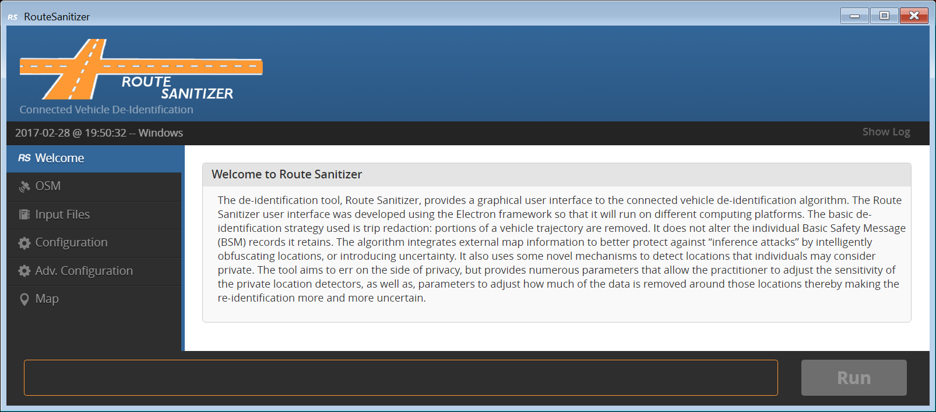

Figure : RouteSanitizer Welcome tab.

* Component 1 is the main menu consisting of several “Tabs” arrange vertically. The tabs are arranged in workflow order.
  + **Welcome Tab**: General information and links to documentation.
  + **OSM Tab:** Generation of Route Sanitizer map data from OSM files.Configuration Tab: Settings that control how de-identification is performed.
  + **Input Files Tab**: Specify the file(s) that should be de-identified.
  + **Configuration Tab:** The option and parameter settings that determine how de-identification will be performed, where the map data will be obtained, and where the final output will be written.
  + **Adv. Configuration Tab:** Advanced parameter settings that rarely need modification.
  + **Map Tab**: Visualization of annotated de-identification files.
* Component 2 will populate with the input or output fields associated with a task or a map to review sanitized trips when a menu tab is clicked. In Fig. 6, the configuration tab is selected (highlighted in blue) in Component 1 and the configuration input/output screen is displayed in Component 2.
* Component 3 contains buttons that operate on the user input provided in Component 2.
* Component 4 is the button that executes the de-identification code. The program will run using the current settings provided in the various screens.
* Component 5 (Progress Bar) shows the progress of an executing de-identification run.
* Component 6 (Status Bar) displays feedback from the executing de-identification program when something “abnormal” occurs.

## User Interface Elements

Each tab in the user interface consists of a collection of various interactive input elements, called “widgets”, which can be manipulated by the user to specify parameters that control the use of the Route Sanitizer algorithm. The types of widgets used in the interface are buttons, text boxes, numerical boxes with increment/decrement buttons, and sliders. The Configuration Tab contains an example of each of the widget types.

### Button

Button widgets are activated by clicking on the button. They are used to initiate specific actions such as loading or saving configuration parameters to a file and running the Route Sanitizer algorithm. Many of the buttons invoke display of an operating specific file system explorer dialog box for specifying directories and/or file names.

### Text Box

Currently, text box widgets are only used in Route Sanitizer for specifying the field names of CSV input files on the Configuration Tab. The easiest way to input a new value in a text box is to highlight the default number and type in a new text string. Note that for the CSV field names, the text string is case sensitive, i.e., using the correct upper case and lower case letters matter.

### Numerical Box

Numerical box widgets are used to display and input new values for numerical parameters. A few parameters are limited to integer values while most parameter values can be decimal numbers.

The values for many of the numerical parameters must be within minimum and/or maximum limits as specified in the parameter description. Invalid numerical entries will result in the display of a popup error dialog window describing the invalid entry. Note that there are also machine dependent extreme upper and lower limits for both integer and decimal numerical values which are not flagged, but these numbers are extremely large or small and outside of any practical consideration. Also note that while any number of digits can be entered for decimal numbers, generally only about 15 significant digits (the double precision limit) will be used by the algorithm.

There are two ways to change the value of parameters in numerical boxes:

1. In many cases, the easiest way to input a new value in a numerical box is to highlight the default number and type in a new number.
2. Values in numerical boxes can also be changed using the increment/decrement arrow buttons on the right side of the numerical box widget. For most numerical values on the Configuration Tab, the increment/decrement buttons change the value by 1 for integer values and by 0.01 for decimal values. On the OSM Tab the increment/decrement buttons change the latitude/longitude values by 0.0001 (1/10,000) of a degree.

### Slider

The slider widget is an on/off switch. It is typically used to enable or disable user input for particular parameter values. Turn the slider on or off by clicking anywhere in the slider widget (oval area). When the slider is “on”, the slider circle will be on the right and the background will be orange. When the slider is “off”, the slider circle will be on the left and the background will be grey.

### Tooltip

Most of the widgets have an associated “tooltip” that pops up when the user “hovers” the cursor over an input field, menu item, or button for about 2 seconds without clicking the item. The tooltip is a short reminder or hint of what the widget does or how its value is used in the sanitization process. Fig. ? illustrates a tooltip example on the configuration page.

## Workflow Outline

The following outline shows the typical trajectory database de-identification workflow using *Route Sanitizer*:

1. Convert an Open Street Map (OSM) file into a sanitization algorithm map “quad” file (OSM Tab).
2. The default configuration parameters should be sufficient to perform quality de-identification. If new parameters are desired, select a representative sample of trajectories from your database. Use this sample to establish the necessary configuration settings.
3. Load the sample trajectory database (Input Files Tab).

Configure the sanitization process (Configuration Tab).

* 1. Initially use the default parameter settings.
  2. Select a quad file that covers the region containing the trajectories in the database being processed.
  3. Specify an output directory.
  4. Ensure KML output is selected (only when running a sample).

If needed, configure advanced parameters for the sanitization process (Adv. Configuration Tab).

Run the De-Identification Algorithm (RUN button in the lower right-hand corner)

* 1. The RUN button becomes active when there is at least one input file and an output directory is selected. settings

Review one or more of the sample trips by loading their annotated KML files (Map tab).

Modify the configuration based on analysis of the results.

When a final set of configuration has been established, load the entire trajectory database.

* 1. Ensure KML output is disabled in the final configuration settings.

Run the De-Identification Algorithm on the entire dataset.

Specific details about each of the tabs used above are provided in the sections that follow along with screen shots of the application.

## OSM (Open Street Map)

The *OSM* tab (Fig. 7) provides a tool for converting an Open Street Map data file into the quad file that the sanitization algorithm uses to de-identify trajectory databases. OSM files contain more information than the de-identification algorithm requires, so this preprocessing step reduces and formats the OSM information into a form that the sanitization algorithm can use efficiently. More details and examples of OSM and quad files are given in Appendix A.

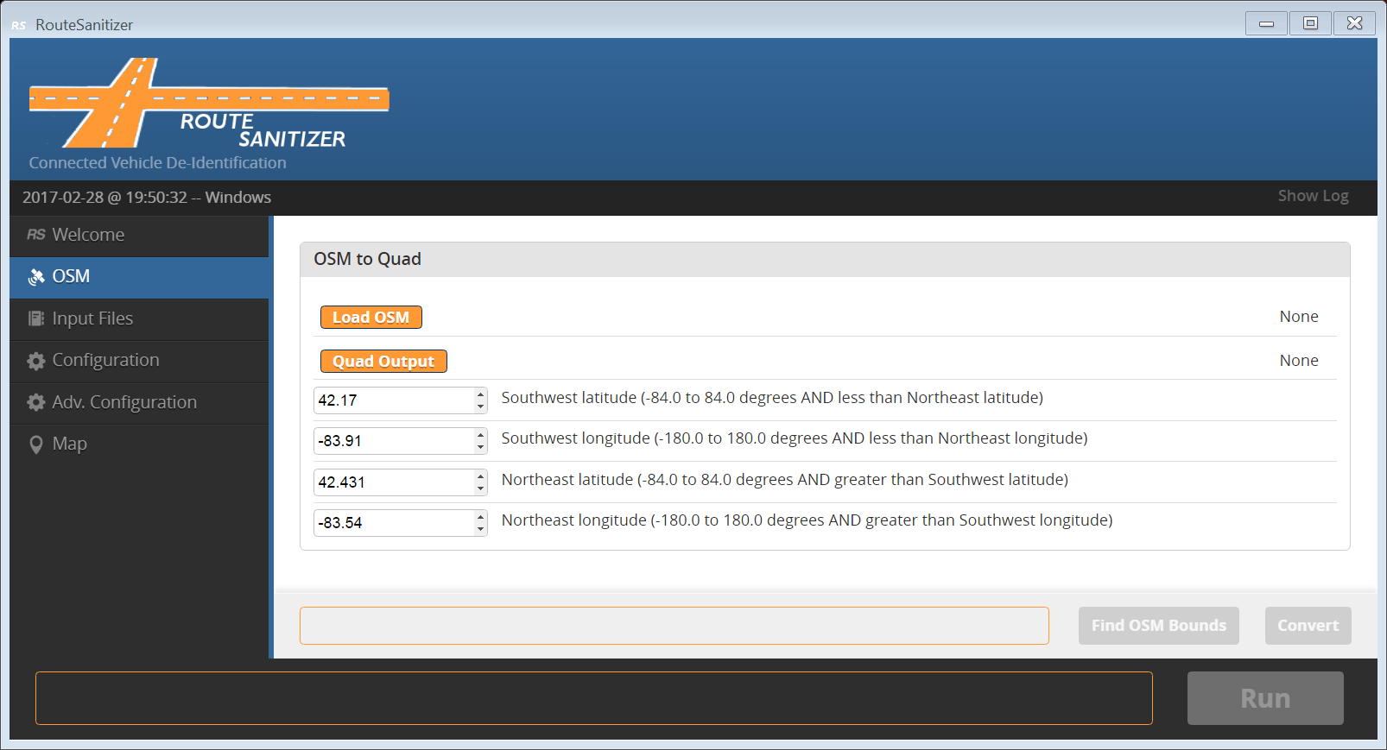

Figure : RouteSanitizer OSM tab.

The following buttons in the OSM section will display the typical file system explorer dialog box for file selection. (For additional folder navigation options on a Mac, click the small down arrow at the end of the ***Save As*** text box.)

* ***Load OSM*:**  Specify the OSM file to be converted. The OSM file must contain valid OSM data, but the file extension does not matter.
* ***Quad Output***: Specify a location and filename for the quad file output from the OSM conversion. The filename extension specified for the quad files does not matter, but for clarity we suggest using “quad”.

Since OSM files can be large (countries or continents), the user can designate a smaller, more focused, area which encloses the geo- coordinates of the trips in their database. The following parameters control the bounding coordinates of the smaller area.

* ***Southwest latitude (degrees)***: Latitude of the lower left corner of the smaller bounding box. [-84.0 to 84.0 degrees, must be less than Northeast latitude.]
* ***Southwest longitude (degrees)***: Longitude of the lower left corner of the smaller bounding box. [-180.0 to 180.0 degrees, must be less than Northeast longitude.]
* ***Northeast latitude (degrees)***: Latitude of the upper right corner of the smaller bounding box. [-84.0 to 84.0 degrees, must be greater than Southwest latitude.]
* ***Northeast longitude (degrees)***: Longitude of the upper right corner of the smaller bounding box. [-180.0 to 180.0 degrees, must be greater than Southwest longitude.]

The following buttons:

* ***Find OSM Bounds***: Before specifying new latitude/longitude bounds, it may be useful to know the bounds of the currently specified OSM file. Click the ***Find OSM Bounds*** to obtain and display these bounds (Fig. 8). Obtaining the minimum and maximum latitude and longitude values in the OSM file requires reading the files, which may take some time for a large OSM file.
* ***Convert***: Click this button to generate the quad file. A progress bar indicates how far along the conversion process is. Any OSM features needed by the sanitization algorithm (e.g., road segments) that are partially within the bounds designated by the user will be included in the resulting quad file.

Once a quad file is created using the *OSM* tab, it will be automatically selected as the map information to be used for sanitization and the quad file’s name will be pre-populated in the ***Configuration*** tab.

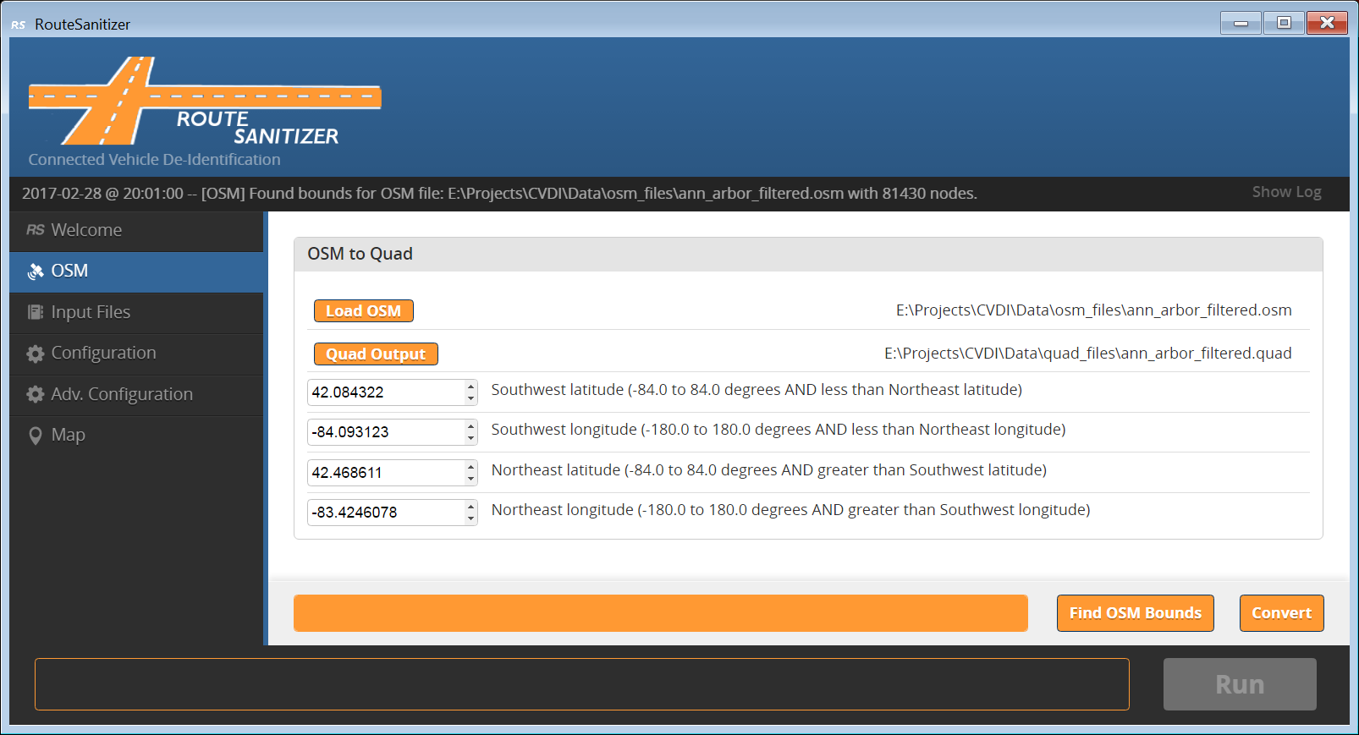

Figure 8: RouteSanitizer OSM tab, OSM bounds retrieved from OSM file.

## Input Files

The ***Input Files*** tab (Fig. 9) is an interface that allows the user to specify one or more files that contain vehicle trajectories. Currently, input files must be in comma-separated value (CSV) format (additional formats may be integrated in the future). You need at least one loaded input file to run the de-identification algorithm. The ***Run*** button becomes active when at least one input file is specified and an output directory has been selected on the Configuration tab.

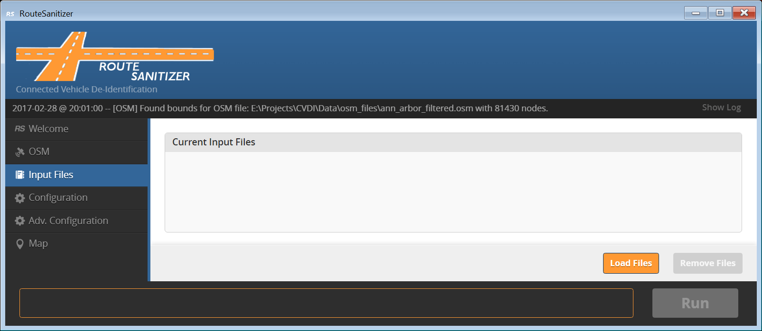

Figure : RouteSanitizer Input Files tab, load files.

The following buttons in the Input Files section will display the typical file system explorer dialog box for file selection:

* ***Load Files***: Click this button to specify input files. In the file browser pop-up, navigate to the directory where the input files are located and select one or more files. After clicking the ***Open*** button the selected files will be displayed in the ***Current Input Files*** list on the Input Files tab. Additional input files can be selected by clicking the Load Files button again.
* ***Remove Files*** : To remove files from the ***Current Input Files*** list, click on each file that you want to remove and then click the Remove Files button (Fig. 10). Multiple files can be removed from the list at once.

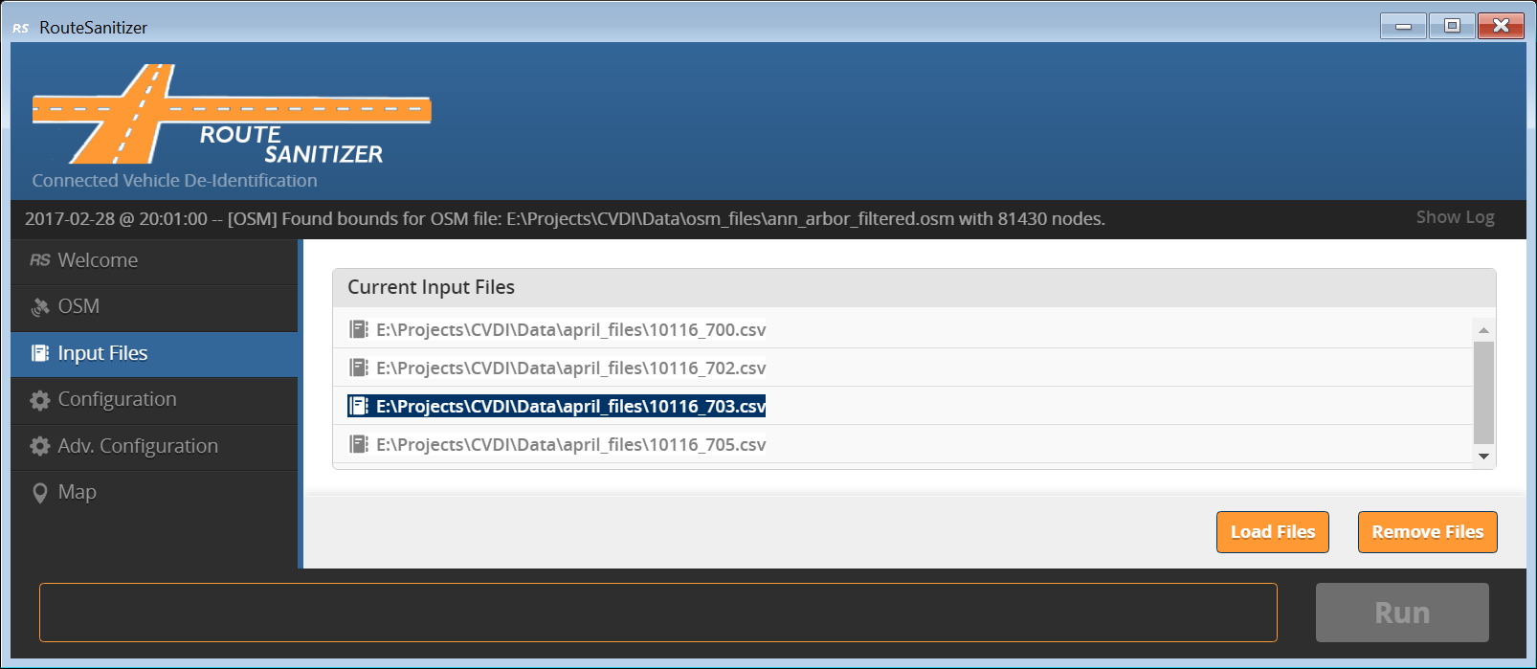

Figure : RouteSanitizer Input Files tab, remove files.

## Configuration

The de-identification process is customizable. In other words, the user can determine the sensitivity of critical interval detectors and how privacy intervals are constructed. This translates roughly into determining what is considered private and how those private locations are protected against re-identification attacks.

Configuration is broken down into four sections: I/O (Input/Output), CSV Field Names, KML Options, and Privacy Intervals. The configuration parameters are described in the sections that follow.

### I/O

The I/O section of the Configuration tab (Fig. 11) allows the user to specify input and output files required for the de-identification process. Clicking on buttons in the I/O section results in the display of an operating specific file/directory finder window in which the user can navigate to the desired file name or folder.

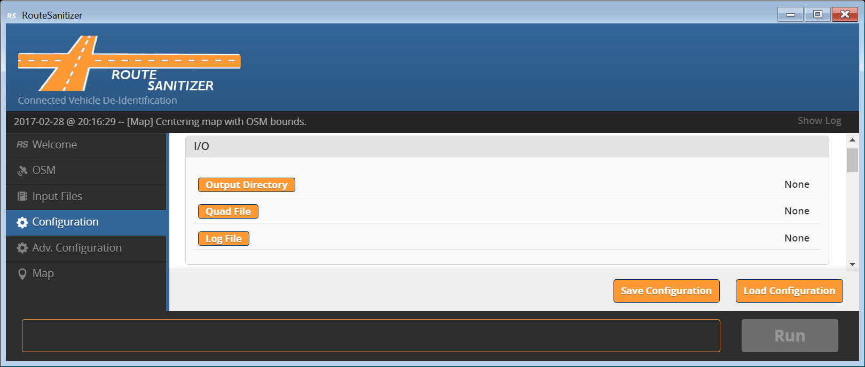

Figure 11: Configuration tab, I/O parameters.

The following directory and files can be modified in the I/O section of the Configuration tab:

* ***Output Directory:*** This button allows the user to specify where the output of the sanitization process will be written. Results of the de-identification process will be output to a subdirectory structure under the specified output directory. Details for the output directory structure are given in Appendix A.
* ***Quad File*:** The user must also designate a quad file that contains the map information to be used during the de-identification process. If a quad file was generated on the OSM tab during the current execution of the Route Sanitizer application, the name of that file will be automatically specified to the right of the Quad File button. However, a different quad file can be specified using the Quad File button. If a quad file is not specified, the algorithm can still be run but map fitting will not be used to improve the de-identification process.
* ***Log File***: The user may designate a log file to which the Route Sanitizer application will write information that might be useful in the case of problems with the user interface or the de-identification process.

### CSV Field Names

The input files specified in the Input Files tab contain comma separated rows of data. The first line of each file contains a comma separated list of field names that corresponds to the comma separated data values. The field names may differ from one batch of CSV files to another, but must be the same in all of the files processed in one run. The route sanitizer needs to know the field names as specified in the CSV files. In the ***CSV Field Names*** section of the Configuration tab (Fig. 12), the user must specify the field names used in the input CSV files for each of the five key fields used to perform de-identification.

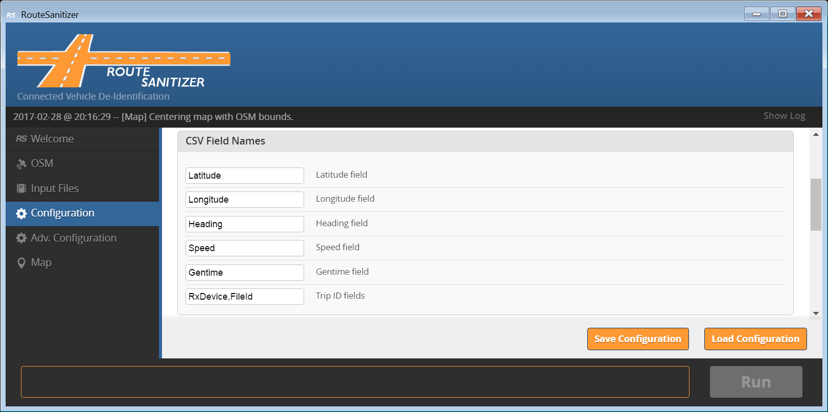

Figure 12: Configuration tab, CSV Field Name parameters.

The following case-sensitive parameters can be modified in the CSV Field Names section:

* ***Latitude*:** Field name of single column containing latitude values. [Default: “Latitude”]
* ***Longitude*:** Field name of single column containing longitude values. [Default: “Longitude”]
* ***Heading*:** Field name of single column containing heading values. [Default: “Heading”]
* ***Speed:*** Field name of single column containing speed values. [Default: “Speed”]
* ***Gentime***: Name of single value generated time values. [Default: “Gentime”]
* ***Trip ID:*** Comma separated list of field names corresponding to multiple columns which together specifiy a unique identifier for each row of data. [Default: “RxDevice,FileID”]

### KML Options

In the **KML Options** section of the Configuration tab (Fig. 13) the user can specify whether or not KML map files will be output for each input file processed. The files are written to a separate KML subdirectory under the ***Output Directory*** specified in the ***I/O*** section of the ***Configuration*** tab. When a large number of trips are being processed, generating KML files may slow down the performance of the algorithm significantly. If KML files are generated, the implicit and explicit map fitting boxes can be included; this increases the size of each KML file. The best approach to take when rendering de-identification results is to sample a small subset of trajectories, and then de-identify those with the parameter settings being investigated.

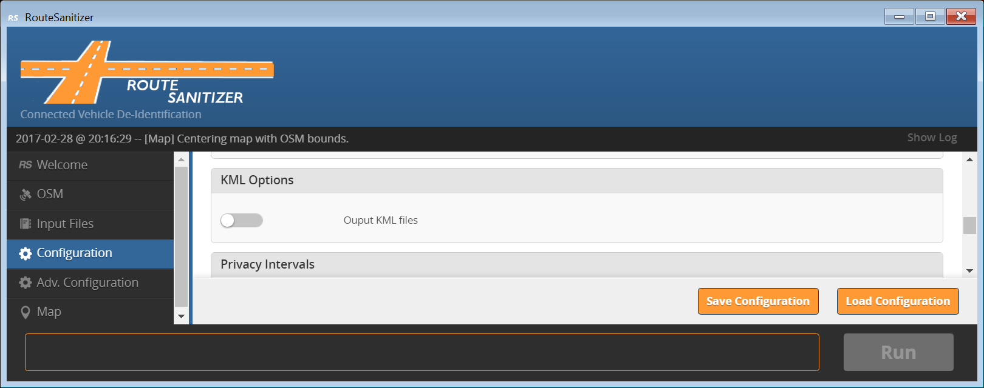

Figure 13: Configuration tab, KML Options.

The following parameters can be modified in the KML Options section:

* ***Output KML Files***: If toggled on (circle to right, orange background), an individual KML file will be generated for each trajectory processed in the de-identification process.

### Privacy Intervals

In the **Privacy Intervals** section of the Configuration tab (Fig. 14) the user can specify 6 of the 9 parameters controlling how privacy intervals are determined in the de-identification process. As discussed in Part 1, privacy intervals “protect” critical intervals by determining how much of the trajectory surrounding the critical interval should be removed. The amount removed depends on a criterion defined using several metrics. In the Privacy Intervals section of the Configuration tab, each of these metrics includes an input parameter for “Maximum” and “random factor” value. The “Minimum” value for these metrics is rarely changed and is included in the Adv. Configuration tab.

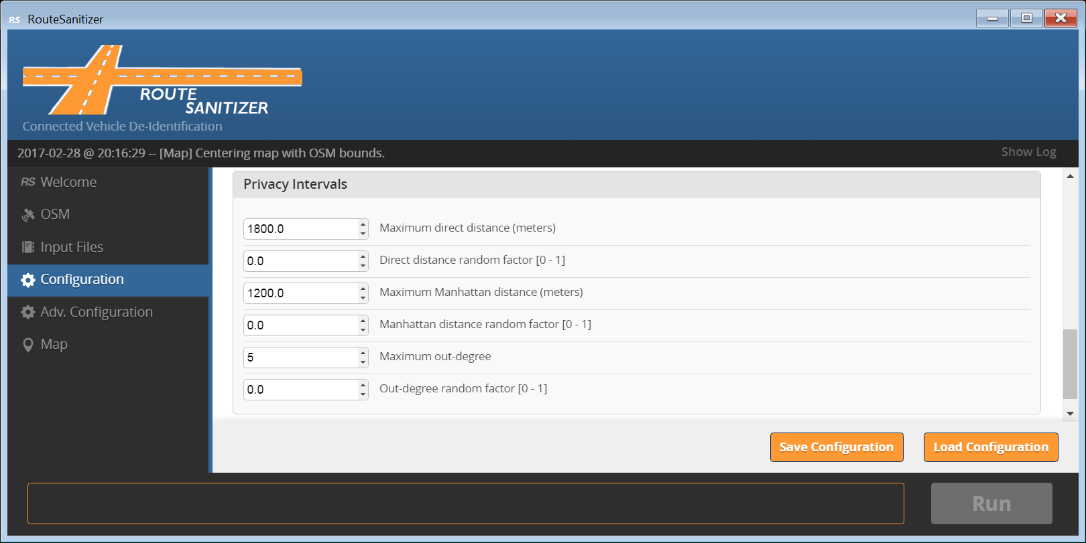

Figure : Configuration tab, Privacy Intervals parameters.

The following parameters can be modified in the Privacy Intervals section:

* ***Maximum direct distance (meters)*:** Maximum direct distance between the start of the privacy interval and the trip point currently being evaluated during de-identification (i.e., the point-to-point distance). This metric provides a radius of protection around each critical interval. [Decimal value in meters, greater than Minimum direct distance on Adv. Configuration tab.]
* ***Direct distance random factor*:** Randomness factor applied to the minimum direct distance. [Decimal value between 0 and 1 inclusive.]
* ***Maximum Manhattan distance (meters)*:** Maximum actual distance traveled over the road network; this is computed using the explicit and implicit boxes generated during map fitting. [Decimal value in meters, greater than Minimum Manhattan distance on Adv. Configuration tab.]
* ***Manhattan distance random factor*:** Randomness factor applied to the minimum Manhattan distance. [Decimal value between 0 and 1 inclusive.]
* ***Maximum intersection out-degree count*:** The maximum number of possible directions a driver could choose at a particular intersection. [Integer value, greater than intersection out-degree count on Adv. Configuration tab.]
* ***Out-degree random factor*:** Randomness factor applied to the minimum out-degree. [Decimal value between 0 and 1 inclusive.]

## Adv. Configuration

Parameters on the Advanced Configuration tab should not need editing in most circumstances. Only change the values for these parameters if you understand how they affect the de-identification process.

### Map-Fit

Parameters in the Map-Fit section of the Adv. Configuration tab (Fig. 15) are used to improve the de-identification process by fitting the vehicle GPS generated route data from the input files to road segments in the OSM map file. As described in Part 2, explicit and implicit boxes are constructed to aid in the map-fitting process.

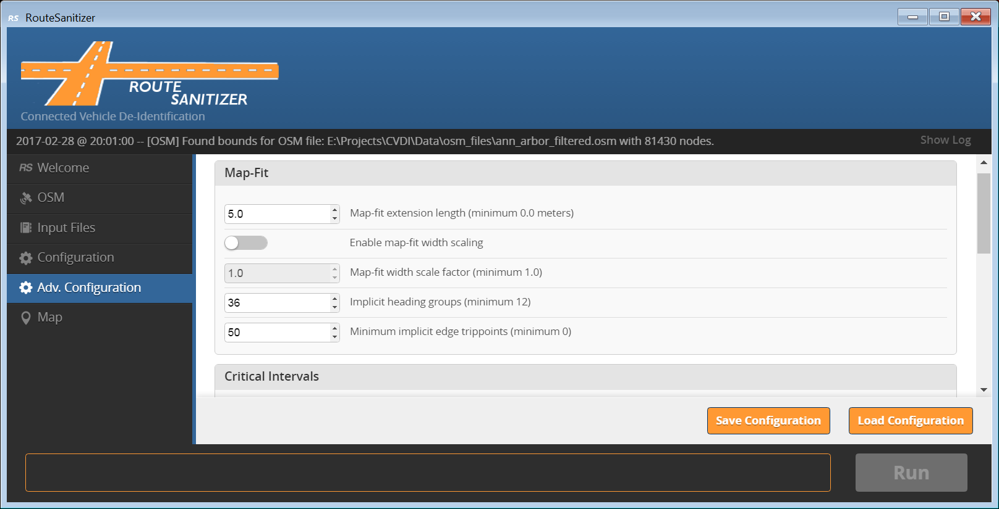

Figure 15: Adv. Configuration tab, Map-Fit parameters.

The following parameters can be modified in the Map-Fit section to control the size of explicit and implicit boxes:

#### Explicit box parameters:

* ***Map-fit extension length (meters)***: Extension length added to both the left and right sides of an explicit map-fit box. Values greater than 0.0 may improve the accuracy of the map-fitting process. [Decimal value greater than or equal to 0.0 meters.]
* ***Enable map-fit width scaling***: If toggled on (circle to right, orange background), the map-fit width scale factor parameter can be modified and will be used in the map-fitting process.
* ***Map-fit width scale factor***: Scale factor to be applied to the width of an explicit map-fit boxes. A scaling factor of 1.0 leaves the values unchanged; a scaling factor of 0.5 makes the boxes half as wide as the pre-specified road width; a scaling factor of 2.0 makes the boxes twice as wide. Width scaling is used to accommodate some drift in GPS measurements without a significant drop in sanitization performance. [Decimal value greater than or equal to 1.0.]

#### Implicit box parameters:

* ***Implicit Heading Groups***: The number of equally sized quadrants to divide the compass rose into. Each quadrant will have a size of 360 degrees divided by the number of quadrants. While a vehicle’s heading remains within a particular quadrant, the vehicle is assumed to remain on an “implicit” road segment. [Integer value greater than or equal to12.]
* ***Minimum Implicit Edge Trippoints***: The minimum number of trajectory points that must be contained in an implicit box before a new one is created. [Integer value greater than or equal to 0.]

### Critical Intervals

Parameters in the Critical intervals section of the Adv. Configuration tab (Fig. 16) are used to determine the critical intervals of trips that should remain private as discussed in Part 1. Since we do not have any additional information about the driver, the sanitization algorithm finds critical intervals by analyzing the characteristics of trip trajectories. Three detectors are used to locate critical intervals:

1. Trip beginning and endpoint detection.
2. Vehicle turnaround detection.
3. Vehicle stop detection.

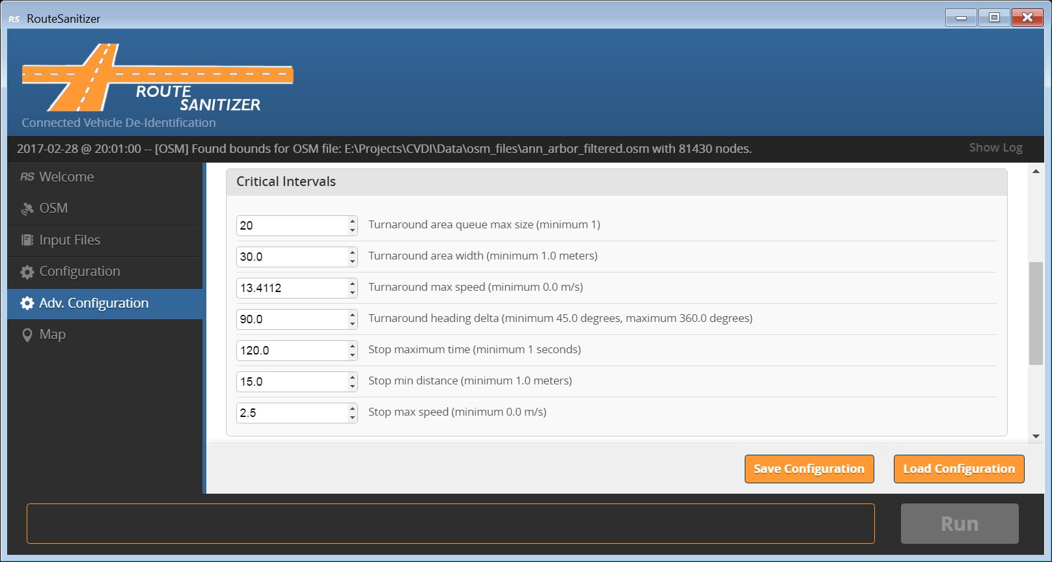

Figure 16: Adv. Configuration tab, Critical Intervals parameters.

The sensitivity of these detectors is controlled by the following modifiable parameters in the Critical Intervals section:

* ***Turnaround area queue max size***: This parameter determines the maximum number of implicit boxes that are maintained to detect a turnaround. This parameter is related to the distance a vehicle can travel before traveling the opposite direction on a previous traveled implicit segment. [Integer value greater than or equal to 1.]
* ***Turnaround area width (meters)***: This parameter determines the width (size) of the implicit boxes generated when OSM information is unavailable; these are the boxes that are stored in the list. Wider boxes increase the likelihood of detecting a turnaround, but could also lead to detecting behavior that should not be considered a turnaround (i.e., a false positive). [Decimal value greater than or equal to 1.0.]
* ***Turnaround max speed (m/s)***: The search for turnarounds only occurs when a vehicle’s speed is below this threshold. [Decimal value greater than or equal to 0.0.]
* ***Turnaround heading delta (degrees)***: The second turnaround detection strategy examines the difference in heading when a vehicle leaves an explicit box and returns to an explicit box. The difference must exceed this configuration parameter to be considered a turnaround. [Decimal value greater than or equal to 45.0 and less than or equal to 360.0.]
* ***Stop maximum time (seconds)***: Consecutive trajectory points over this time period (a subtrajectory) are examined for stop-like behavior. [Decimal value greater than or equal to 11.0.]
* ***Stop min distance (meters)***: A stop is only detected when the distance traveled by a vehicle is less than this threshold over the time period defined by maximum time. [Decimal value greater than or equal to 1.0.]
* ***Stop max speed (m/s)***: When a vehicle’s speed exceeds this threshold no further analysis for stop-like behavior takes place. Lower setting will improve the performance of the de-identification algorithm, but it may cause certain types of stop-like behavior to be missed (e.g., a false negative). [Decimal value greater than or equal to 0.0.]

### Privacy Intervals (Advanced)

As discussed in Part 1, privacy intervals “protect” critical intervals by determining how much of the trajectory surrounding the critical interval should be removed. The amount removed depends on a criterion defined using several metrics. In the Privacy Intervals section of the Adv. Configuration tab, each of these metrics includes an input parameter for “Minimum” value. The “Maximum” and “random factor” value for these metrics is specified on the Configuration tab.

* ***Minimum direct distance (meters)*:** Minimum direct distance between the start of the privacy interval and the trip point currently being evaluated during de-identification (i.e., the point-to-point distance). This metric provides a radius of protection around each critical interval. [Decimal value in meters, greater than or equal to 0.0]
* ***Minimum Manhattan distance (meters)*:** Minimum actual distance traveled over the road network; this is computed using the explicit and implicit boxes generated during map fitting. [Decimal value in meters, greater than or equal to 0.0]
* ***Minimum intersection out-degree count*:** The minimum number of possible directions a driver could choose at a particular intersection. [Integer value, greater than or equal to 0.]

## Map

The *Map* tab allows a user to visually validate sanitized trips. The trip is displayed and annotated using Google Maps within the tab’s main window. There is performance overhead associated with rendering annotated trip files. Although you can load multiple files, this is not recommended.

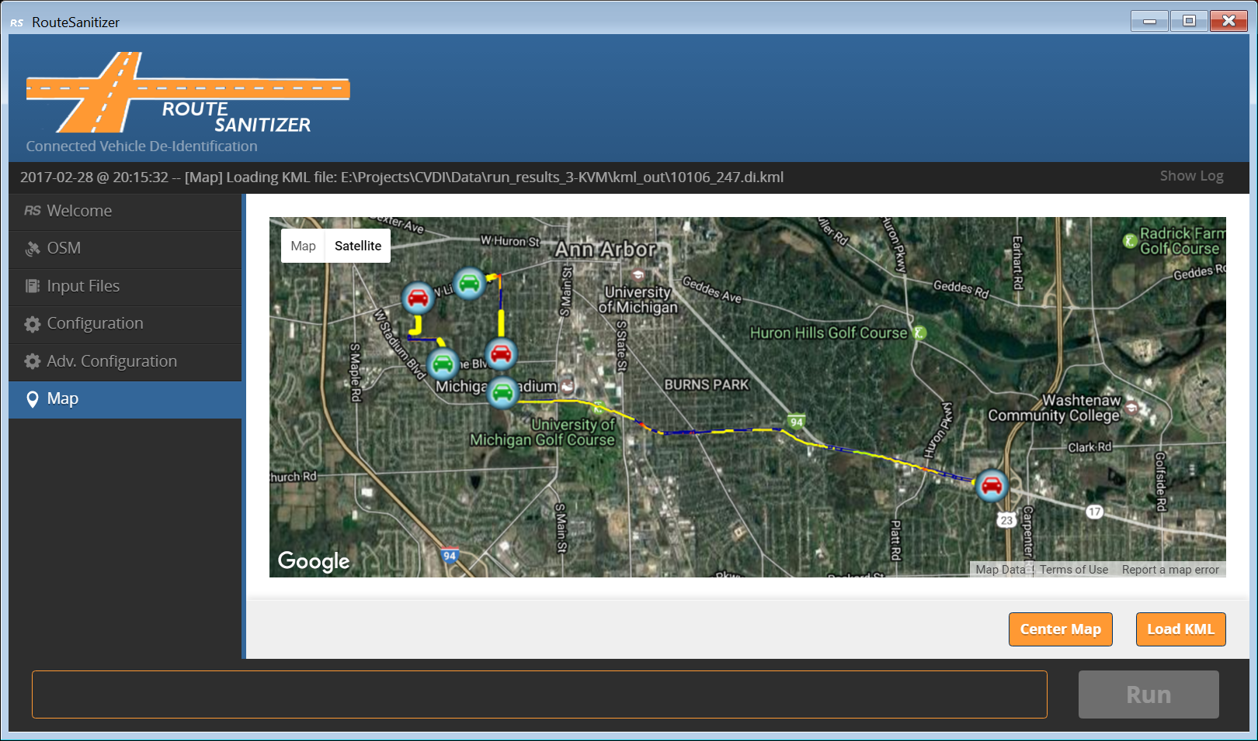

Figure 17: Map tab, KML file loaded.

The following buttons in the Map tab control the map display:

***Load KML***: Click this button to load a KML file and render as a Google map. The typical file system explorer dialog box will be displayed for file selection.

***Center Map***: Click this button to center the map based on the latitude and longitude bounds displayed in the OSM tab. If the loaded KML map is smaller than the latitude and longitude bounds on the OSM tab, the result will be to zoom out so that the user can see where the trip segment is located within the larger map.

Google Maps functions the same way it does in any browser. Click and drag the map to move to a new location; the upper right corner has two buttons that allow you to switch between map and satellite view; the mouse wheel zooms in and out on the map.

To unload or clear the map, simply click one of the other menu items and then return to the map option. The map will be clear and a new file can be loaded at this point.

## Verifying Sanitized Trip Files

The Map tab is provided as a way for practitioners to verify whether the parameters they are using are performing as intended. A random sample of trajectories should be verified, and its size should be determined based on the total number of trajectories in the dataset. The following annotations are made on the de-identified trajectory:

* Vehicle Velocity: trajectory color corresponds to vehicle velocity with red indicating zero velocity and green indicating 80 mph or higher; the color is scaled from red to yellow to green across this dynamic range.
* Critical Intervals: critical intervals are annotated as dark pink lines. Critical intervals triggered by stop detection have an “S” marker, and critical intervals triggered by turnaround detection have a “T” marker.
* Privacy Intervals: privacy intervals are annotated as dark pink lines.

These annotations are used for verification in several ways:

1. Determine whether the annotated critical intervals are at locations that should be considered privacy sensitive.
2. Determine whether locations that should be considered privacy sensitive has NOT been detected as critical intervals. Velocity and Google Map imagery is valuable while inspecting the trip for missed critical intervals.
3. Determine whether the annotated privacy intervals are providing sufficient protection for their connected critical interval. The primary way privacy protection is provided is through intersection out-degree counts; intersections can be visually counted to ensure enough uncertainty is being introduced through the privacy intervals.

## Logging

Route Sanitizer includes two different logging capabilities. The first logging function displays messages pertinent to the user interface and the second logging function writes messages about the de-identification run to a log file.

### User Interface Logging

As noted in the layout section, the component at the top of the user interface is a single-line-width window that displays the latest application feedback message. Fig. 6 shows the location of the logging component. These messages indicate both normal and abnormal application events. To show a scrollable list of events click *Show Log* on the right side of the log area (see Fig. 6).

Logged events include loading or removal of files, changing the configuration, and abnormal events. Log messages are formatted as follows:

{Date} -- [{Severity}] [{Tab Name}] {Message}

{Severity} is optional and can be either [Warning] or [Error] with the entire line displayed in yellow or red, respectively.

### De-identification Run Logging

When the Run button is engaged to start the de-identification process, a log file is created and information about the run is written to this file. The name and location of the log file is specified in the I/O section of the Configuration tab. The information written to the log file includes the names of the quad file and the name of each input file once it has been processed. The following is an example of the contents of the log file:

[DI Log] Building quad from file: E:\Projects\CVDI\Data\osm_files\ann_arbor.quad

[DI] De-identified trip: 10106_251 from file: E:\Projects\CVDI\Data\april_files\10106_251.csv

[DI] De-identified trip: 10106_249 from file: E:\Projects\CVDI\Data\april_files\10106_249.csv

[DI] De-identified trip: 10106_252 from file: E:\Projects\CVDI\Data\april_files\10106_252.csv

## Multi-threading

Route Sanitizer will attempt to use as many processor cores (execution threads) as are available on the host machine when de-identifying multiple trip files. The amount of work that each core performs is balanced based on trip file size. Since each trip can be processed independently, this feature improves the overall performance of the de-identification process for large trip databases.

# Appendix A – File Formats and Directory Structures

## OSM Files

An example OSM file is shown in Fig. 18.

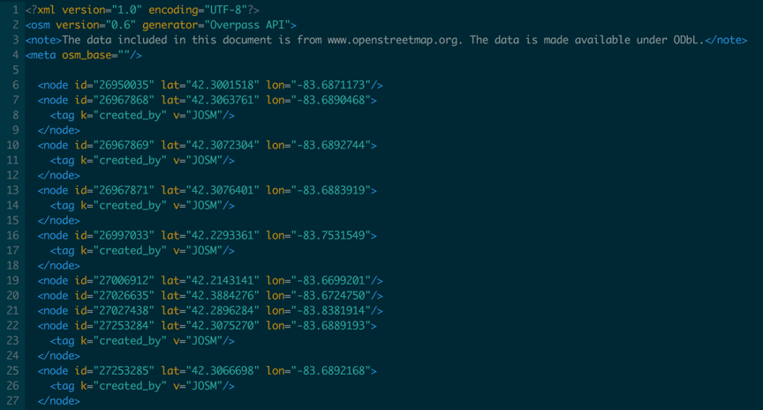

Figure : OSM XML file example.

## Quad Files

An example of a quad file is shown in Fig. 19:

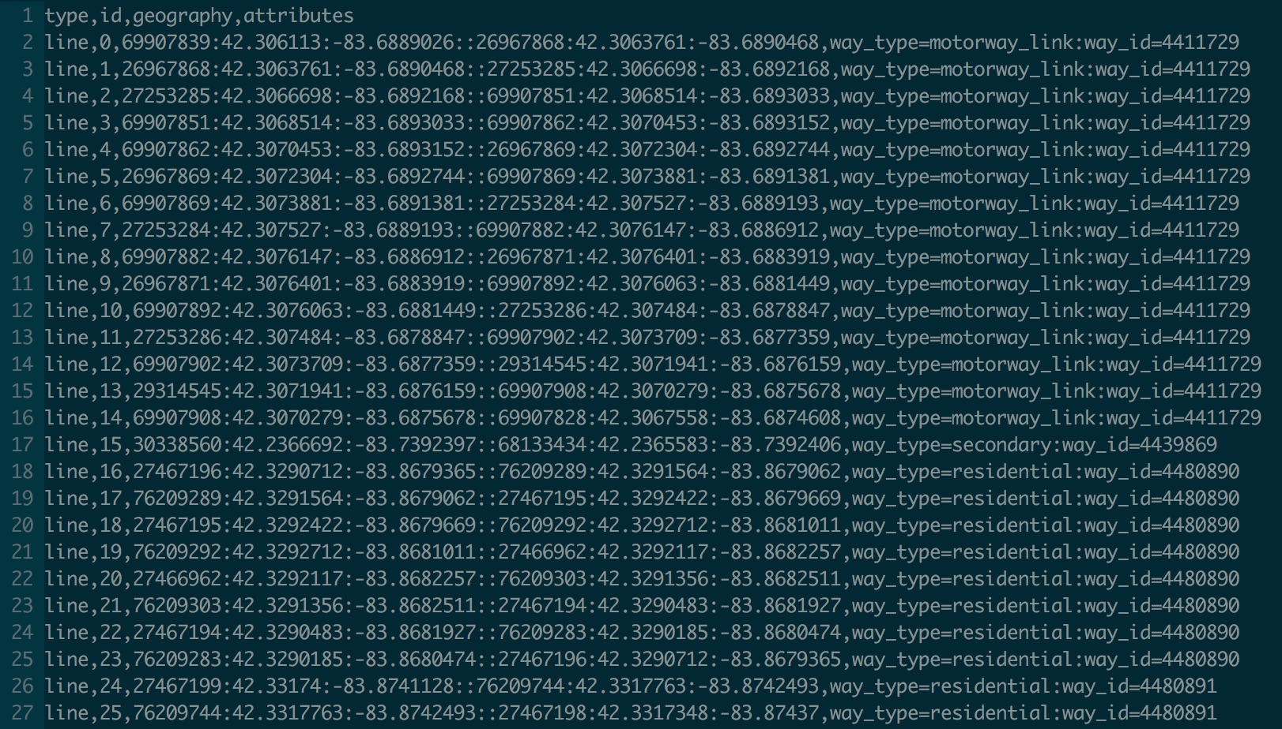

Figure : Quad file example.

## Input CSV Files

An example of a CSV input file is shown in Fig. 20.

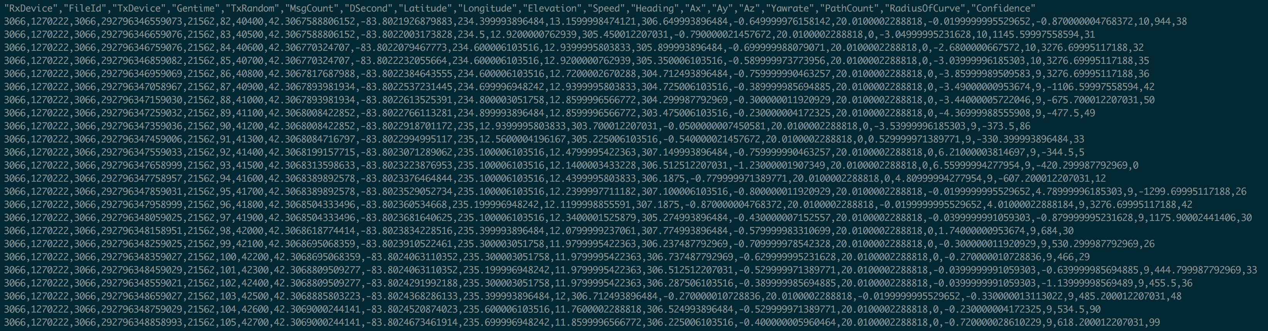

Figure 20: CSV input file with vehicle trajectories.

## Output Directory and File Name Structure

The Output Directory button in the I/O section of the Configuration tab (Fig. 11) allows the user to specify where the output of the sanitization process will be written. A subdirectory will be created in the output director called: **di_out**. This will be the target directory for de-identified files. If KML files are generated, a subdirectory will be created in the output directory called: **kml_out**. This will be the target directory for the annotated KML output files. The following is an example of the output directory structure:

run_results

di_out

10106_248.di.csv

10106_249.di.csv

10106_251.di.csv

kml_out

10106_248.di.kml

10106_249.di.kml

10106_251.di.kml

Output files are named using the same prefix as the input file. Extensions are appended to differentiate the final output files from the input files (even though they should be in separated directories). The following naming rules are applied:

Input file name: **[prefix name].csv**

Output file name: **[prefix name].di.csv**

KML output file name: **[prefix name].di.csv.kml**

1. Major and Minor Version numbers (e.g., 1.1.x) correspond to code versions.